

**DATABASE MANAGEMENT**

**SYTEM**

**Assignment 03**

**Name:** Zubair Ali , Ali Rizwan

**ROLL NUMBERS:** 22I-2591, 22I-2447

**DEGREE PROGRAM:** BS SOFTWARE ENGINEERING (BATCH 2022).

**SECTION:** G.

**SUBMITTED TO:** Sir Zeeshan Khan

**FAST-NUCES Islamabad Campus**

**SUBMISSION DATE: 24 April 2024.**

***QUESTION 1:***

* ***ERD DIAGRAM:***

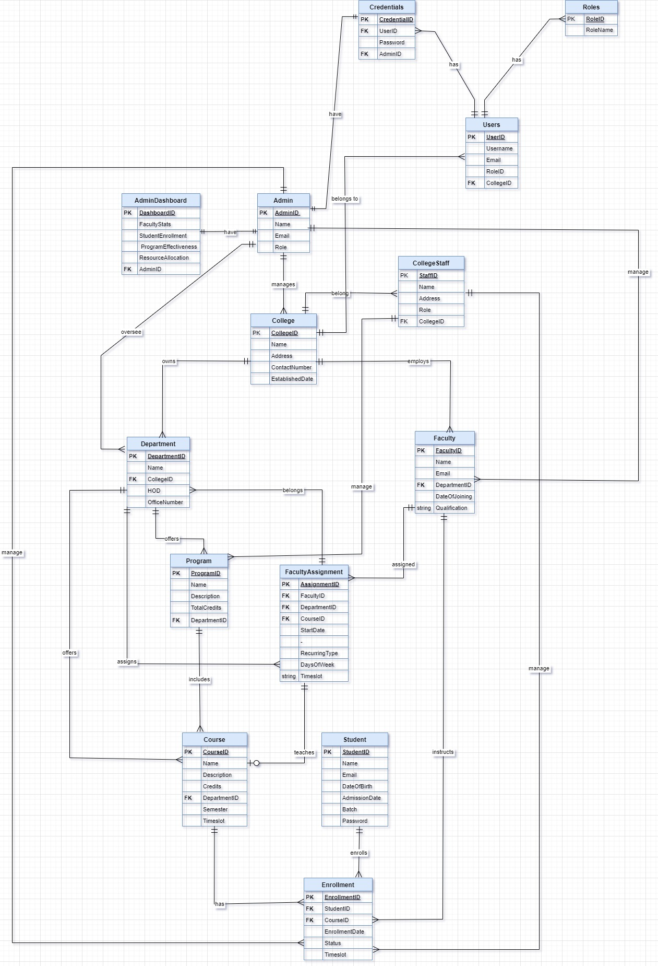

* ***EEED DIAGRAM:***

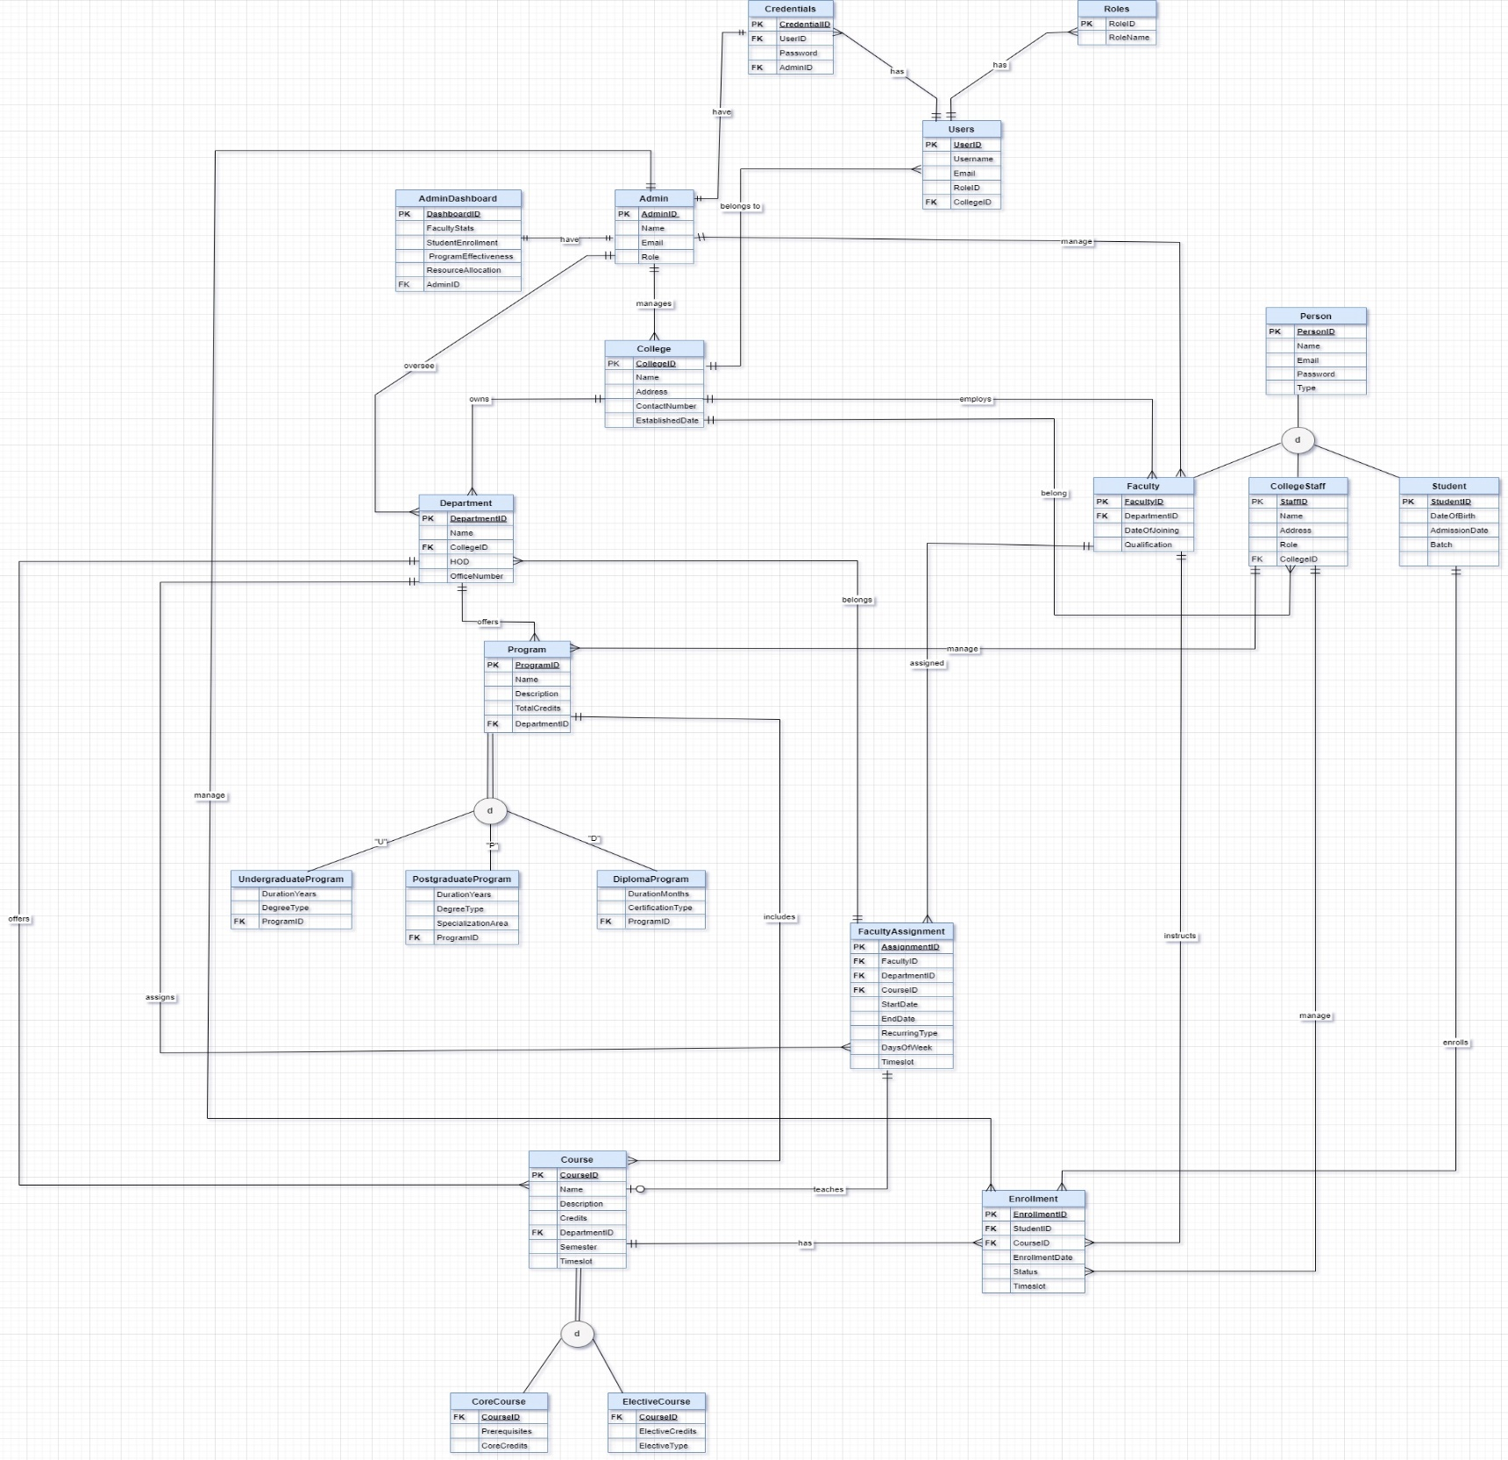

* ***ERD TO RELATONAL SCHEMA***

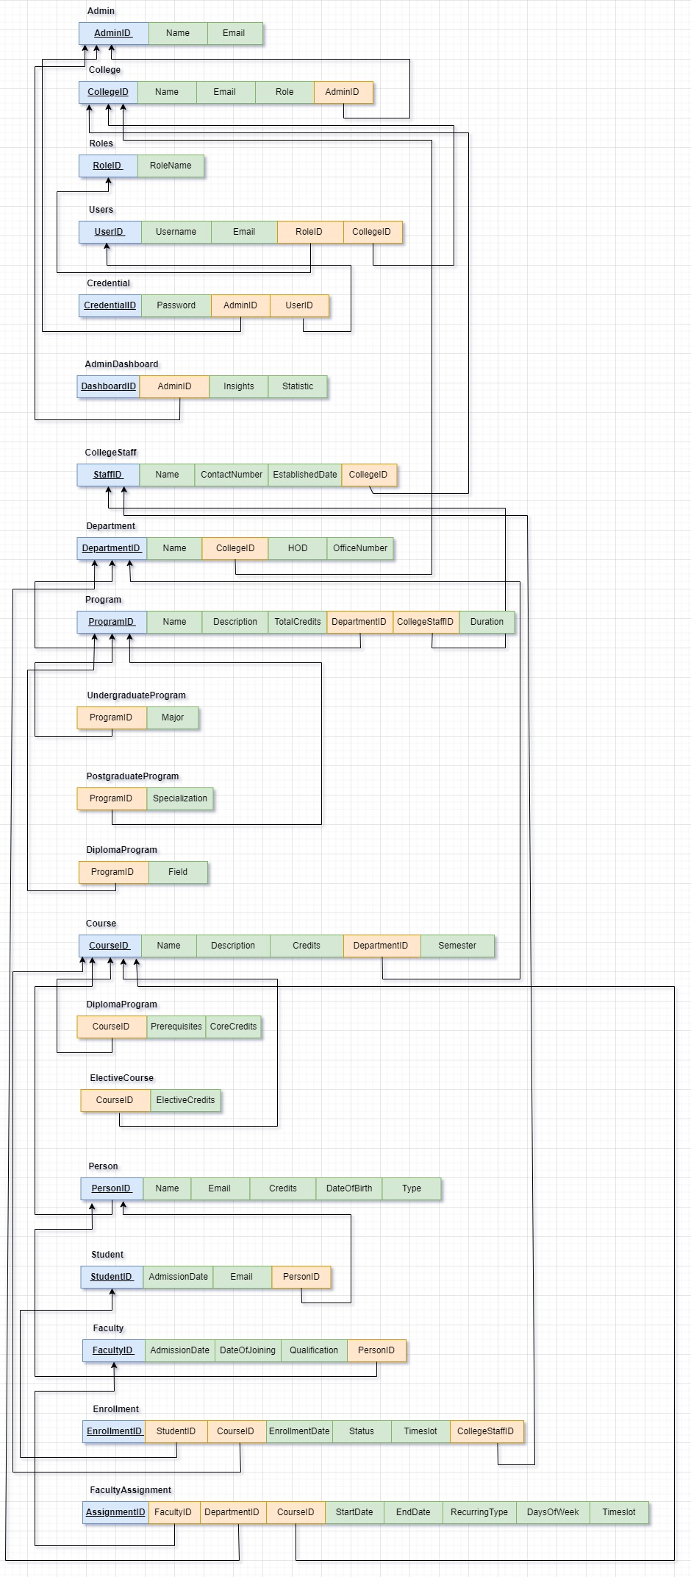

* ***SQL QUERY FOR TABLE CREATION AND CONSTRAINT:***

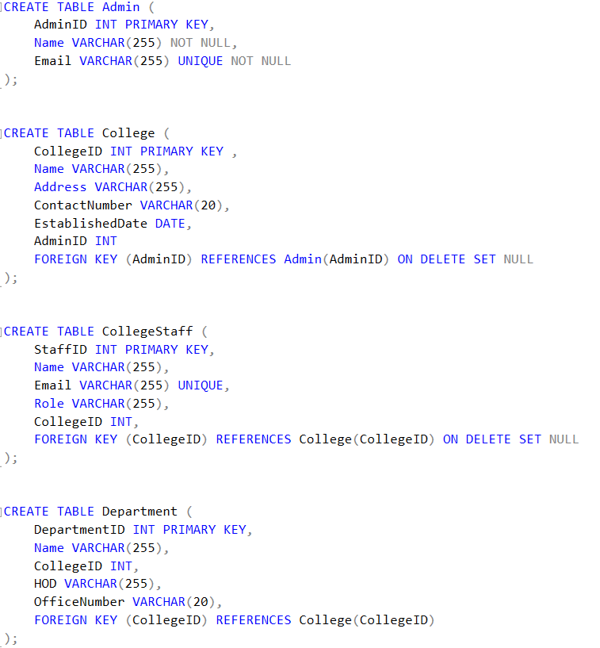

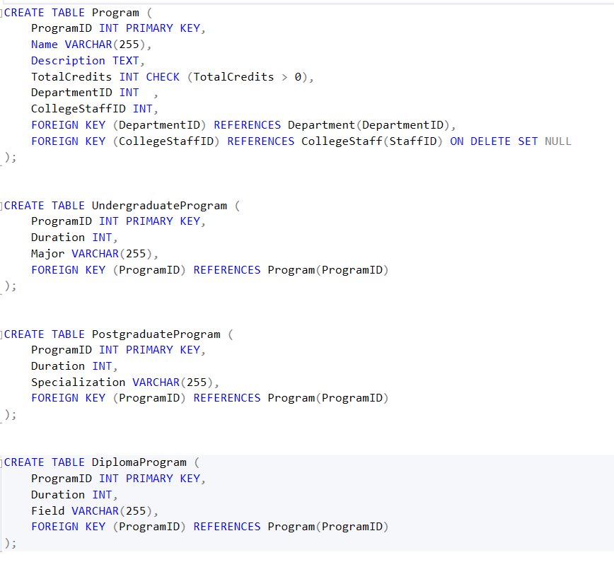

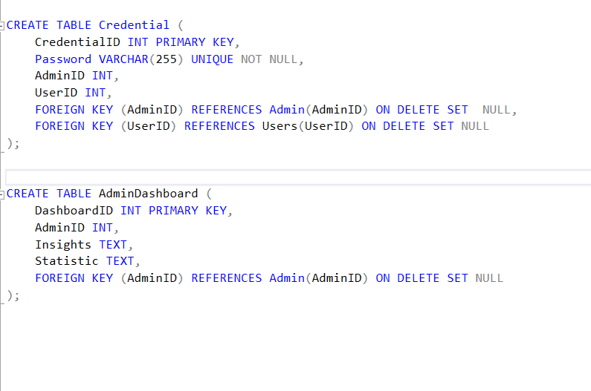

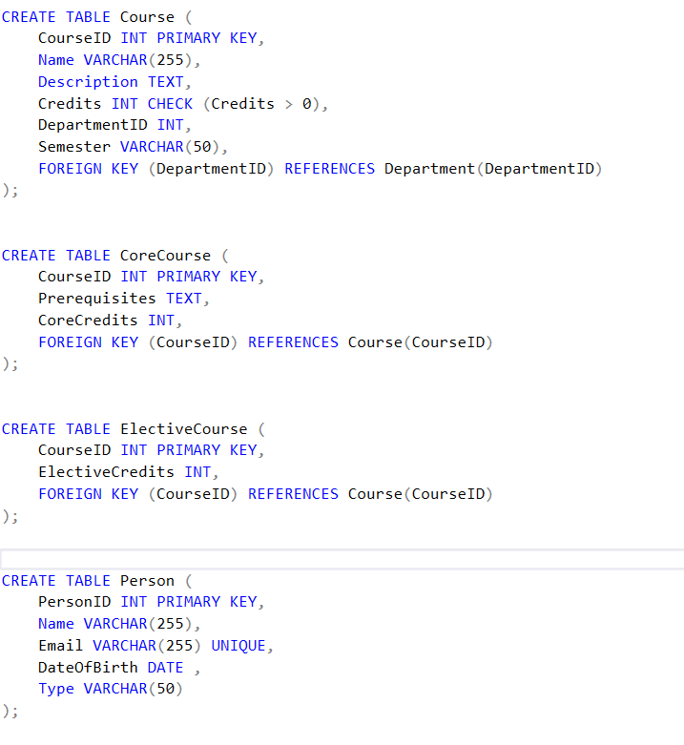

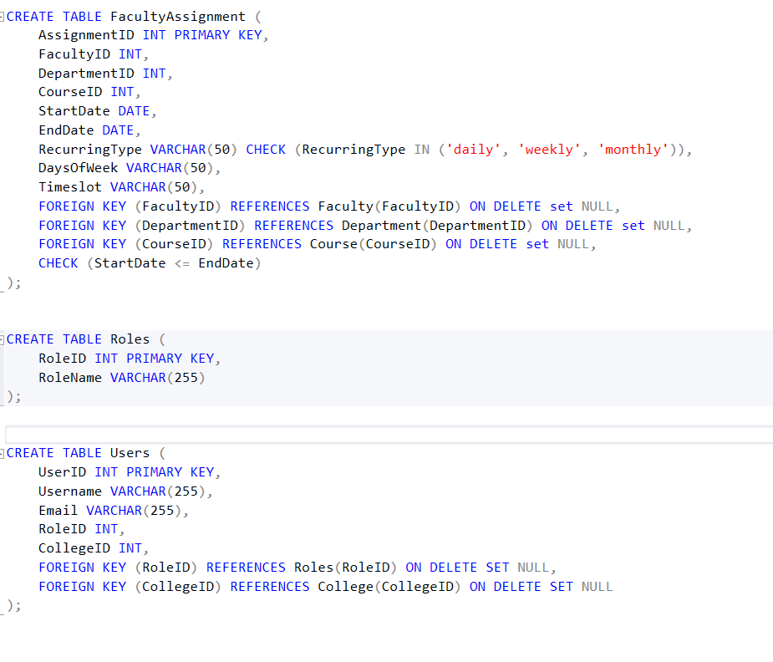

* ***SQL Queries for Data insertion and Fetching:***

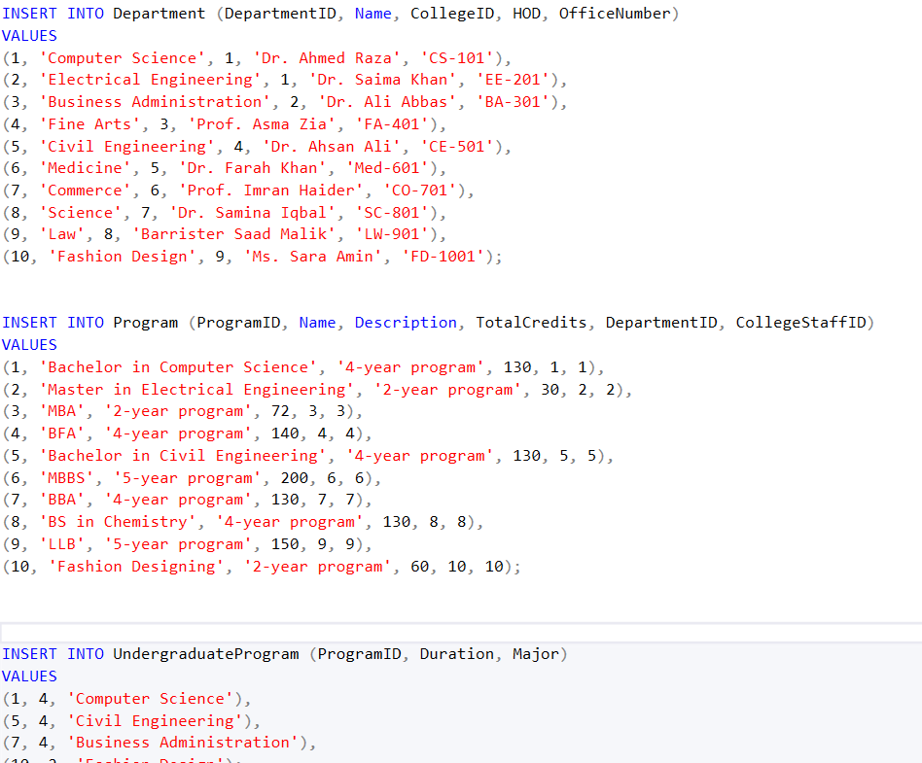

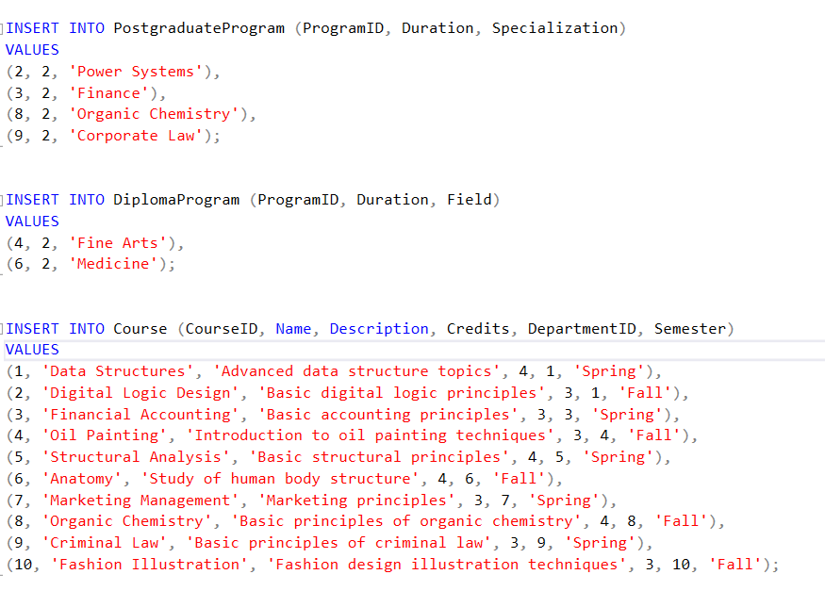

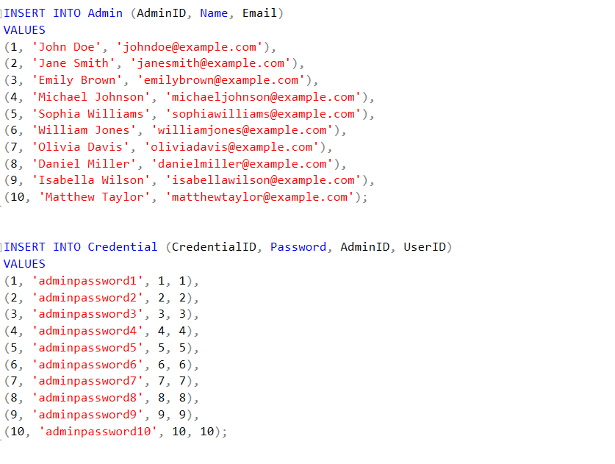

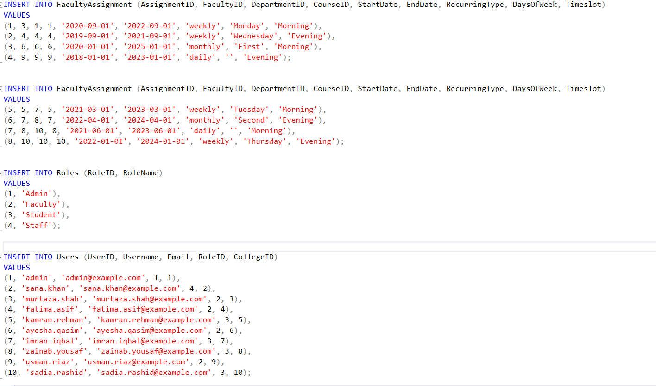

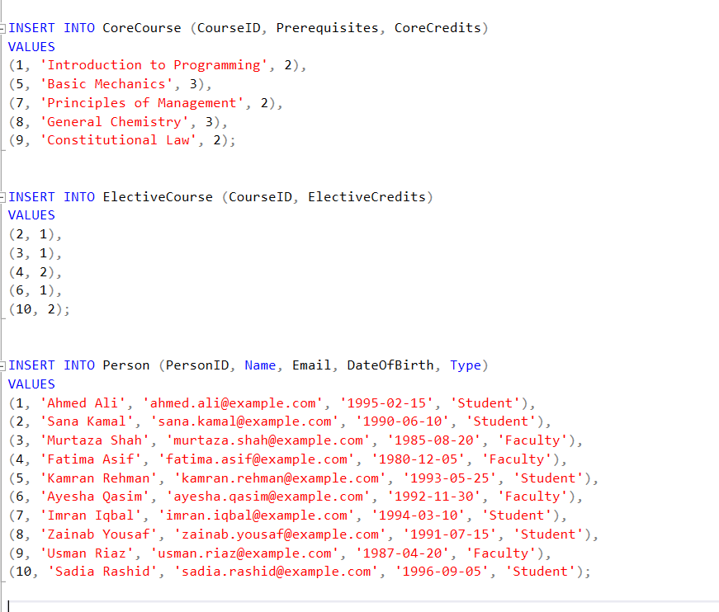

* ***Snapshot of the tuples in tables and results of the SQL queries.***

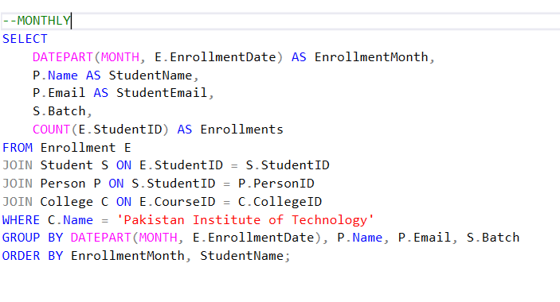

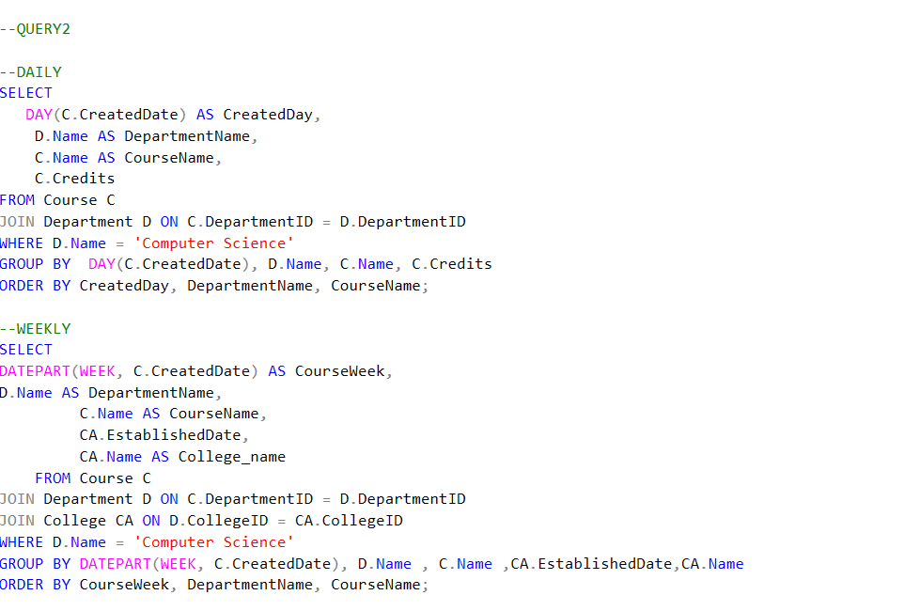

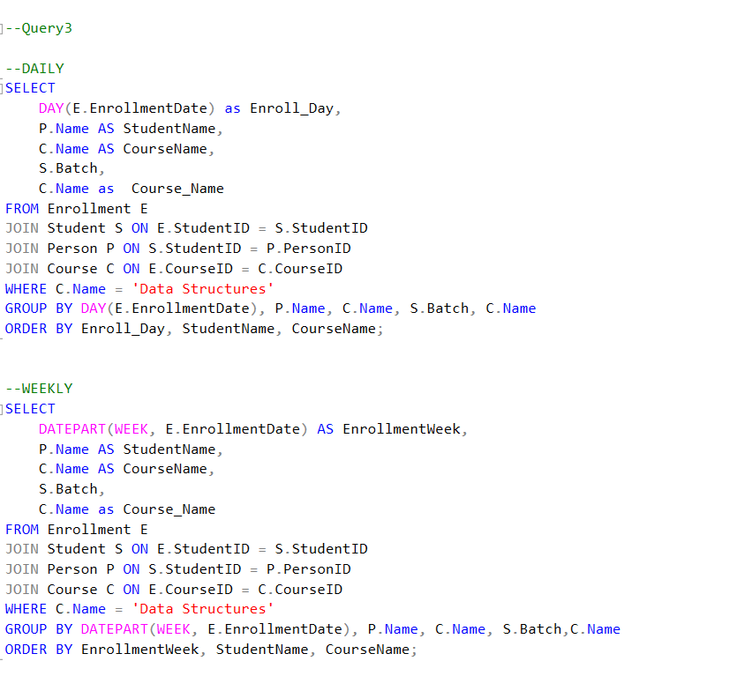

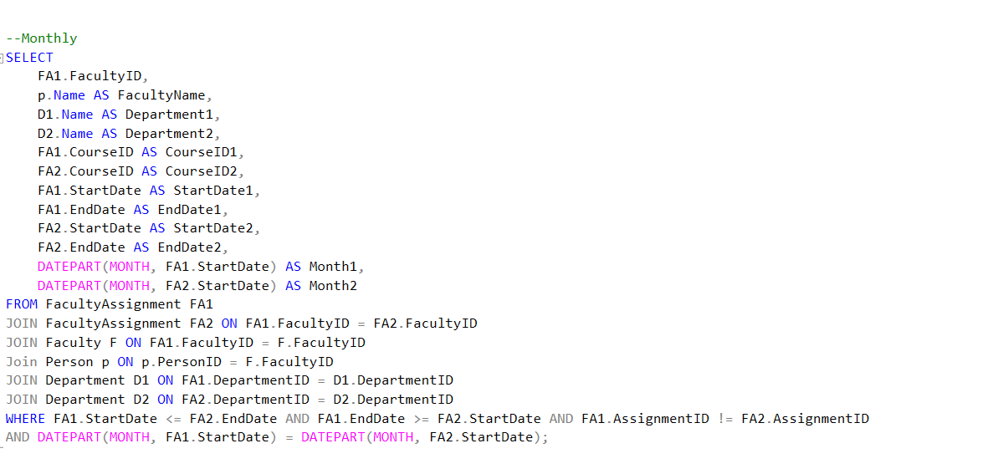

* ***Queries Results:***

***Query Result1:***

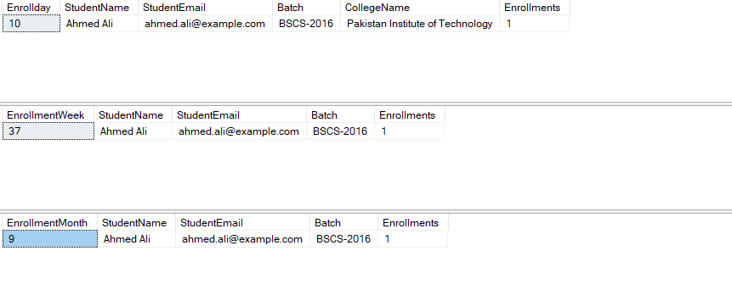

***Query Result2:***

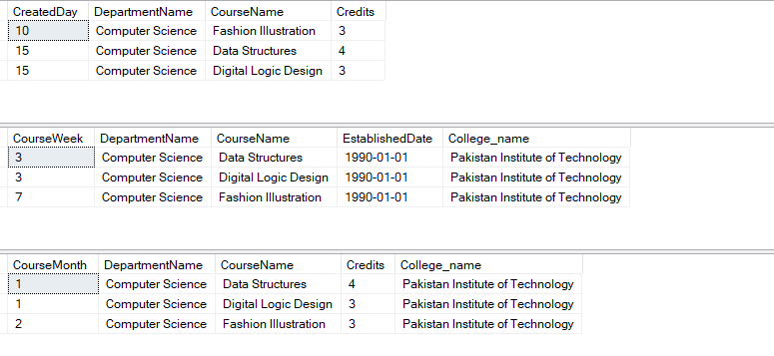

***Query Result3:***

***Query Result4:***

***Query Result5:***

***Query Result6:***

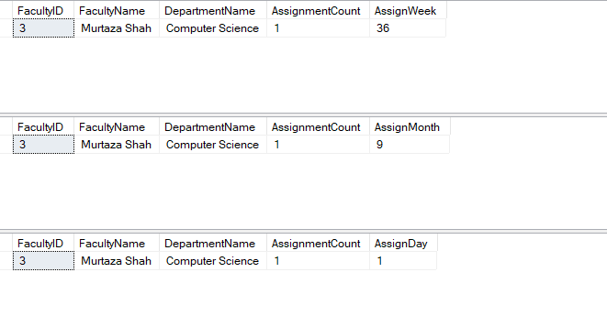

***Query Result7:***

***Query Result 8 And 9:***

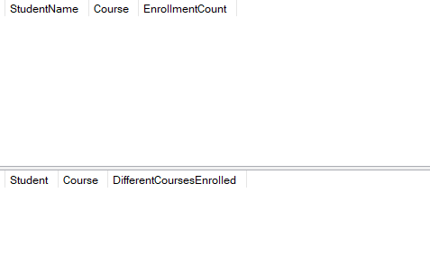

***QUESTION 2:***

***-Anomalies:***

* ***Insertion Anomaly****: This occurs when certain attributes cannot be inserted into the database without the presence of other attributes. For example, in the given scenario, we cannot insert a new course without a student enrolled in it because the table requires a student to be present for every course.*

***Example:*** *If we want to add a new course "C4: Algorithms" to the database but no student is currently enrolled in it, we cannot insert this data into the table.*

* ***Deletion Anomaly:*** *This happens when deleting data unintentionally removes other data that we want to keep. For instance, if we delete a student's record, we also lose the information about the courses they were enrolled in.*

***Example:*** *If we delete the record of student "Ali", we will lose the information about the courses "Database" and "PF" in which he was enrolled.*

* ***Update Anomaly:*** *This occurs when updating data results in inconsistent data because other related data is not updated. For example, if we change the name of a course, we need to update it in multiple places, leading to inconsistencies.*

***Example:*** *If we change the name of the course "Database" to "Database Management Systems" in one record, but fail to update it in all related records, it will lead to inconsistency in the database.*

***2. Normalization up to 3NF:***

|  |  |  |  |  |  |  |  |  |  |
| --- | --- | --- | --- | --- | --- | --- | --- | --- | --- |
| ***Student_id*** | ***Student _City*** | ***StudentName*** | ***CourseOfferid*** | | ***Course_Semester*** | ***CourseOfferedYear*** | ***Course_Grade*** | ***Course ID*** | ***Course Name*** |
| *1* | *Rawalpindi* | *Ali* | | *1* | *Fall* | *2006* | *3.5* | *C1* | *Database* |
| *1* | *Rawalpindi* | *Ali* | | *2* | *Fall* | *2006* | *3.3* | *C2* | *PF* |
| *2* | *Lahore* | *Aleena* | | *3* | *SPRING* | *2007* | *3.1* | *C3* | *OOP* |
| *2* | *Lahore* | *Aleena* | | *2* | *Fall* | *2006* | *3.4* | *C2* | *PF* |

*To normalize the data up to the third normal form (3NF), we need to eliminate the anomalies by breaking down the data into smaller tables and establishing relationships between them. Here's how we can do it:*

***Step 1:*** *Identify the primary keys and remove redundancy.*

***Step 2:*** *Create separate tables for related data.*

***Step 3****: Establish relationships using foreign keys.-*

* ***Normalized Tables:***

***Table 1****: Students*

*Student_id* ***(Primary Key)***

*Student_City*

*StudentName*

***Table 2:*** *Courses*

*Course_ID* ***(Primary Key)***

*Course_Name*

***Table 3:*** *CourseOfferings*

*CourseOfferID* ***(Primary Key)***

*Course_ID* ***(Foreign Key)***

*CourseOfferedYear*

*Course_Semester*

*CourseGrade*

***Table 4:*** *StudentCourses*

*Student_ID* ***(Foreign Key)***

*CourseOfferID* ***(Foreign Key)***

* ***Detailed Normalization Process:***

***Table 1****: Students*

|  |  |  |
| --- | --- | --- |
| ***Student****_id* | ***Student_City*** | ***StudentName*** |
| *1* | *Rawalpindi* | *Ali* |
| *2* | *Lahore* | *Aleena* |

***Table 2****: Courses*

|  |  |
| --- | --- |
| ***Course_ID*** | ***Course_Name*** |
| *C1* | *Database* |
| *C2* | *PF* |
| *C3* | *OOP* |

***Table 3:*** *CourseOfferings*

|  |  |  |  |  |
| --- | --- | --- | --- | --- |
| ***CourseOfferID*** | ***Course_ID*** | ***CourseOfferedYear*** | ***Course_Semester*** | ***CourseGrade*** |
| *1* | *C1* | *2006* | *Fall* | *3.5* |
| *2* | *C2* | *2006* | *Fall* | *3.4* |
| *3* | *C3* | *2007* | *SPRING* | *3.1* |

***Table 4:*** *StudentCourses*

|  |  |
| --- | --- |
| ***Student_ID*** | ***CourseOfferID*** |
| *1* | *1* |
| *1* | *2* |
| *2* | *3* |
| *2* | *2* |